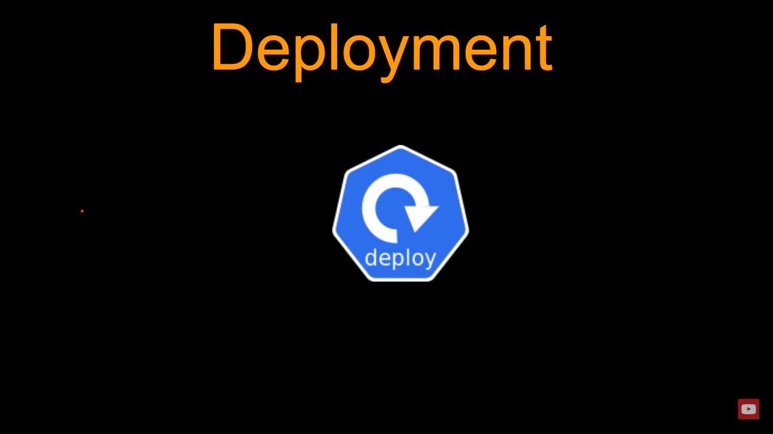

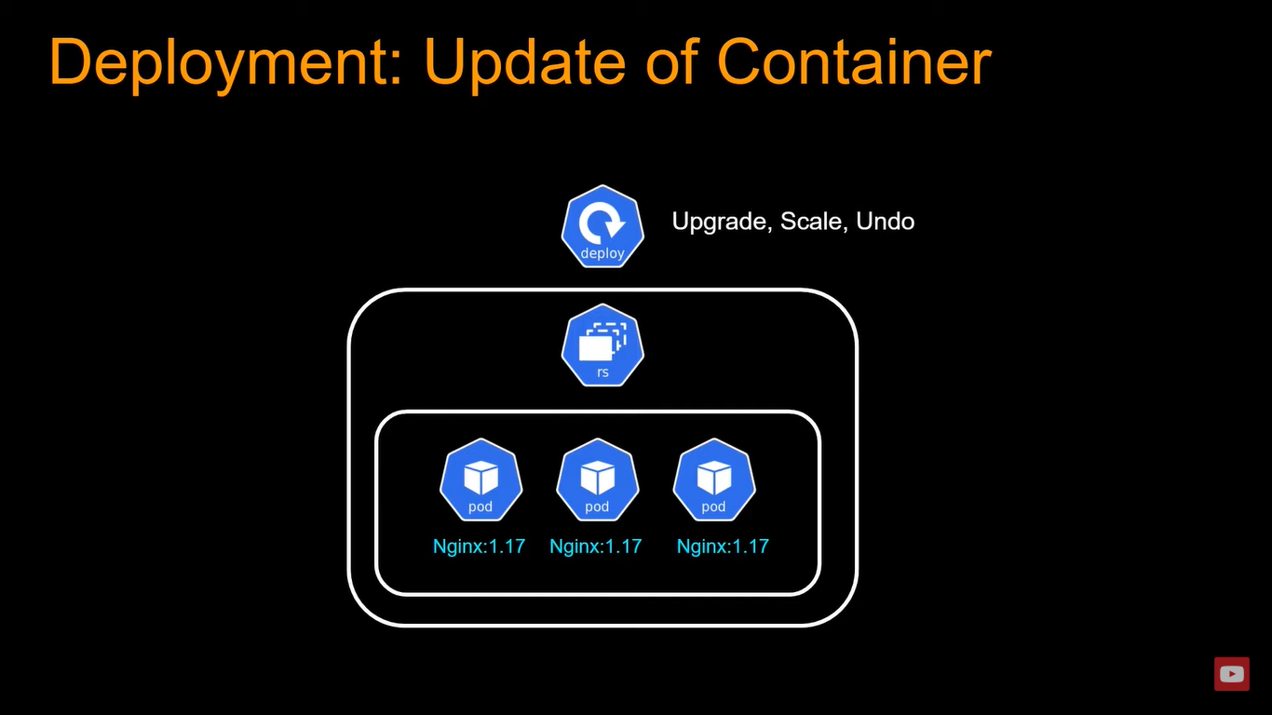

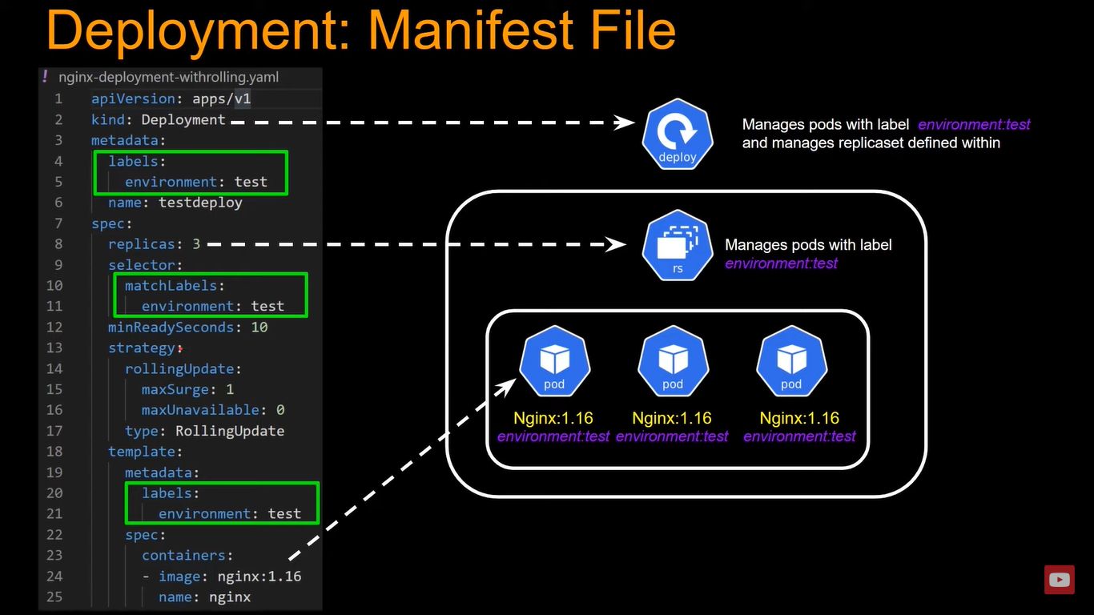

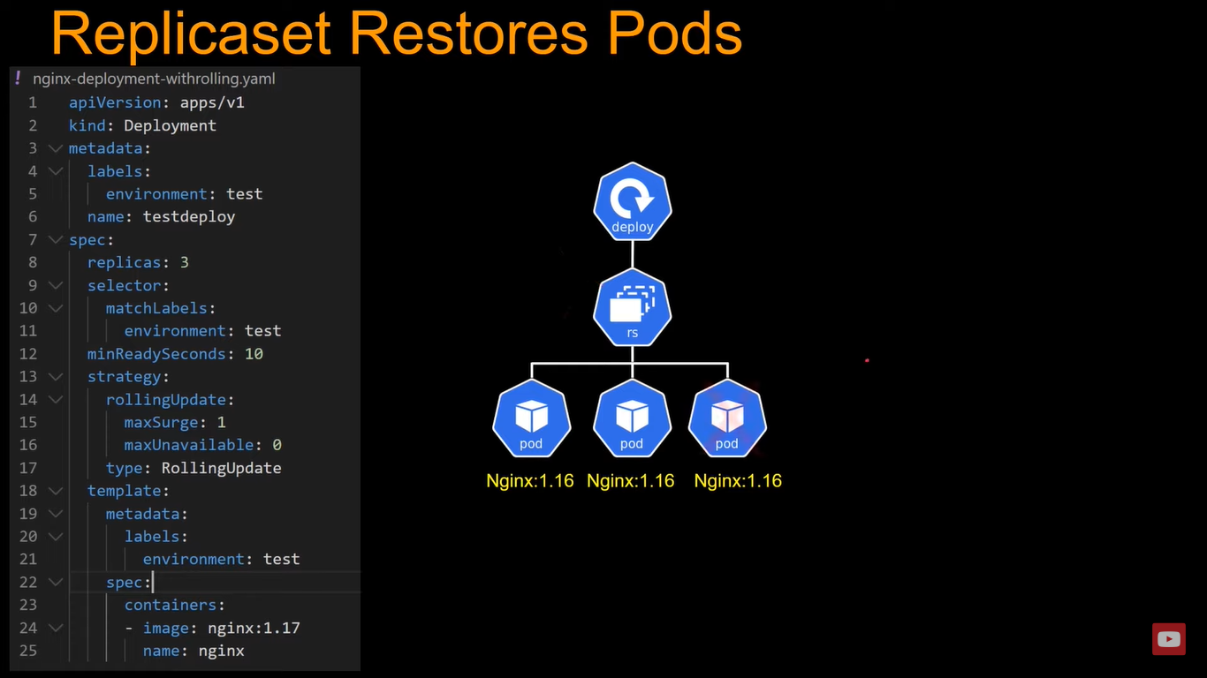

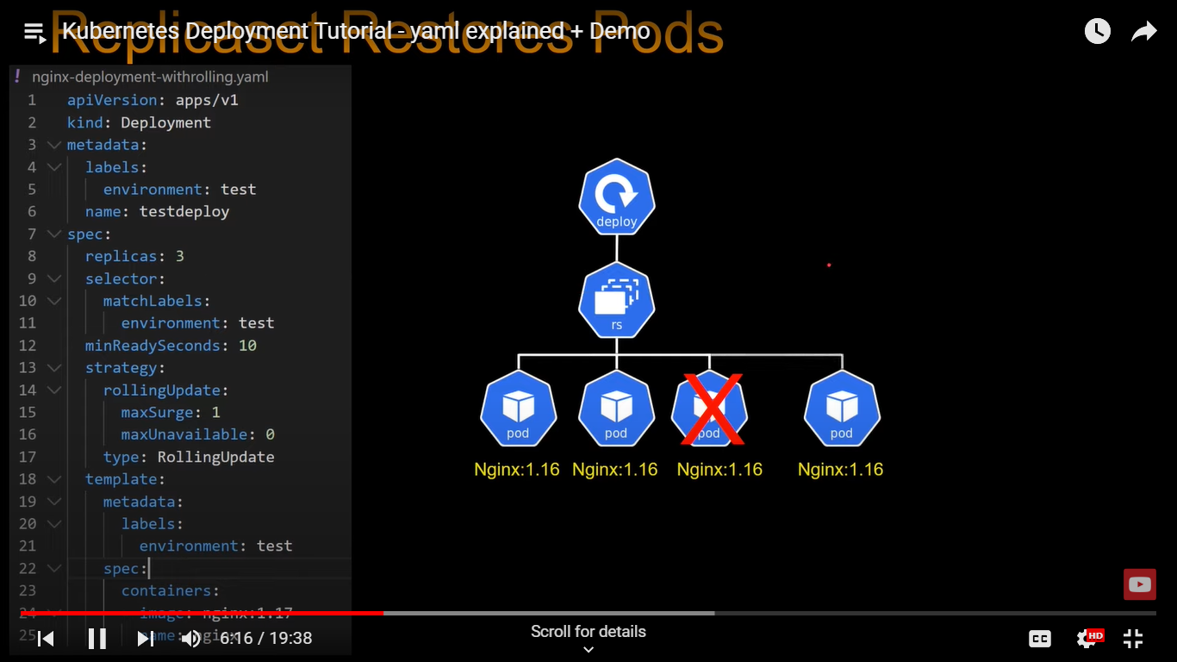

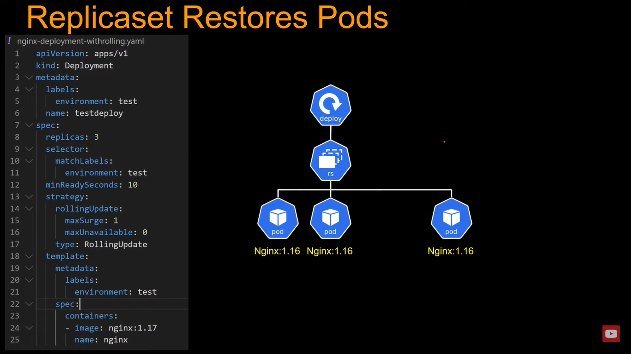

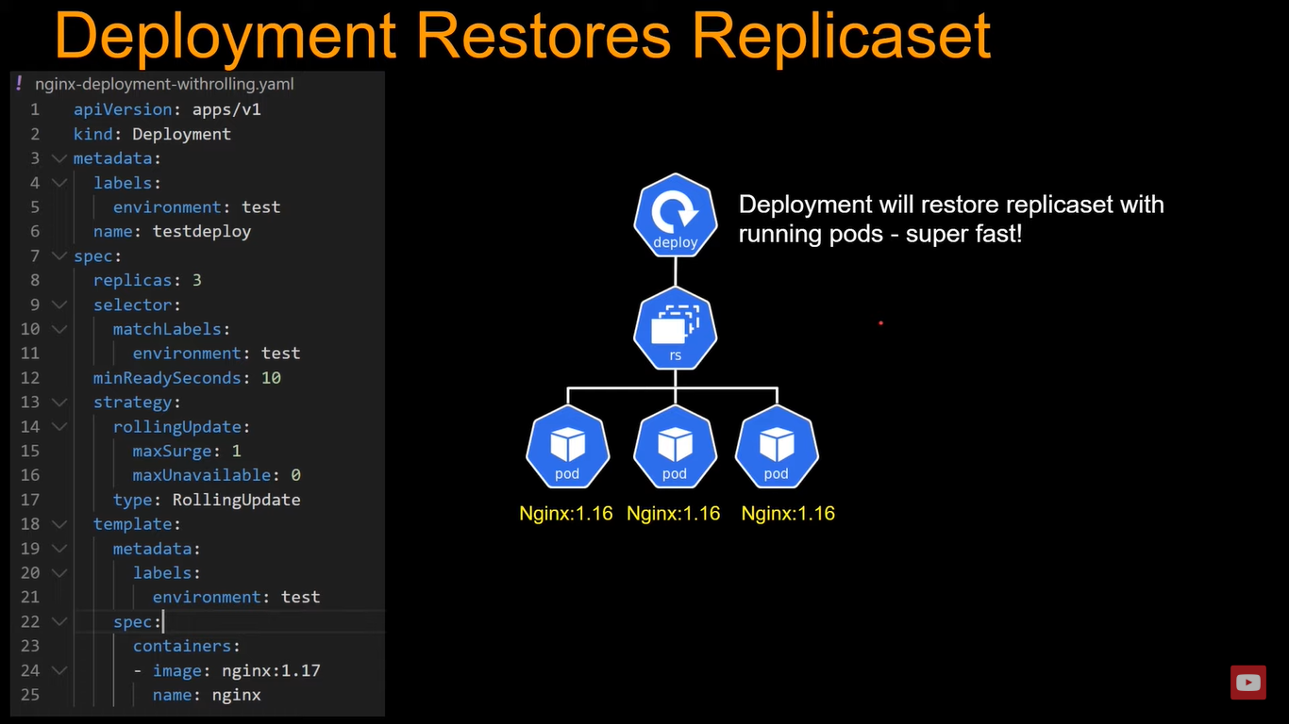

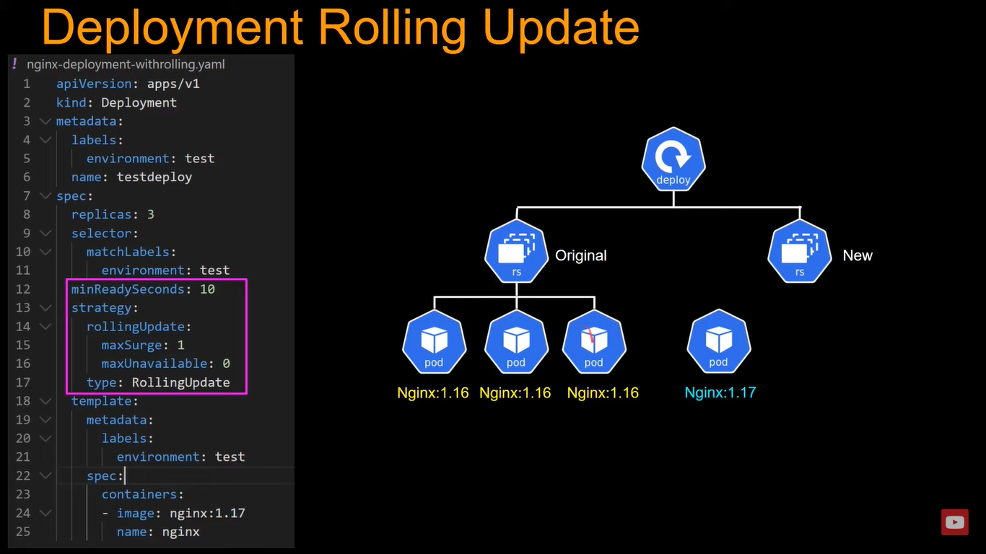

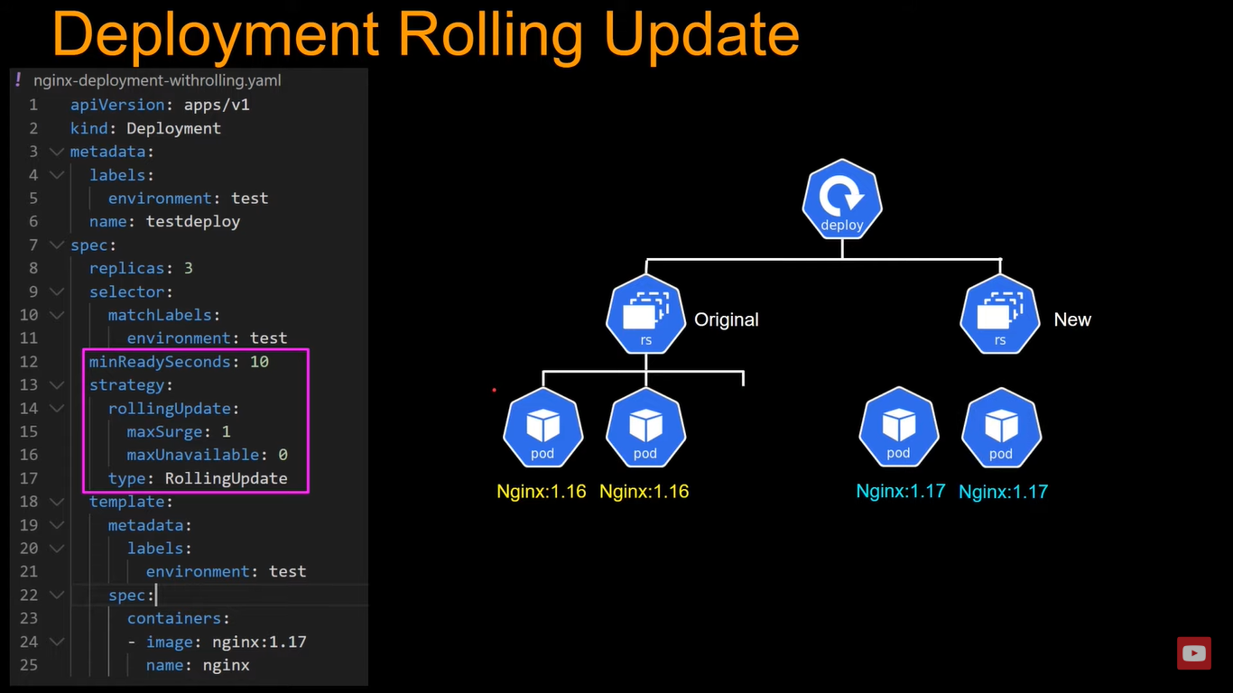

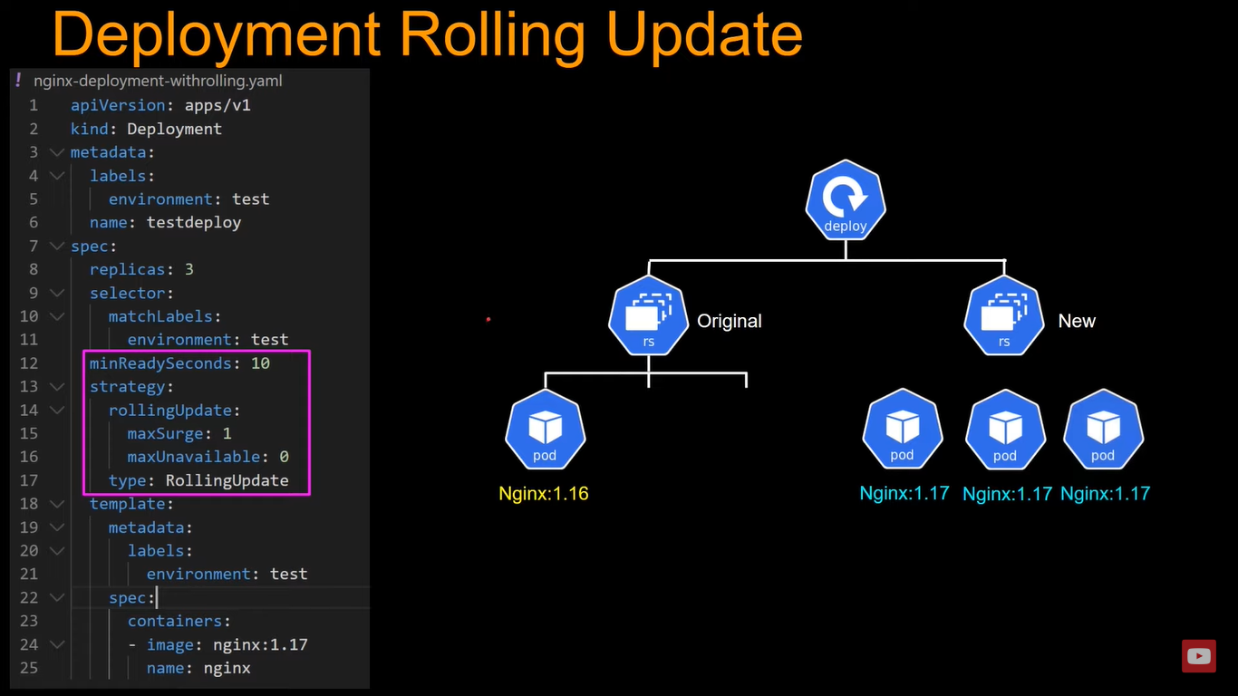

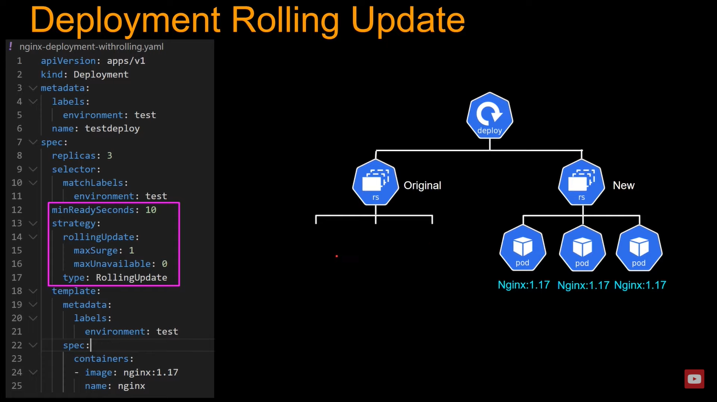

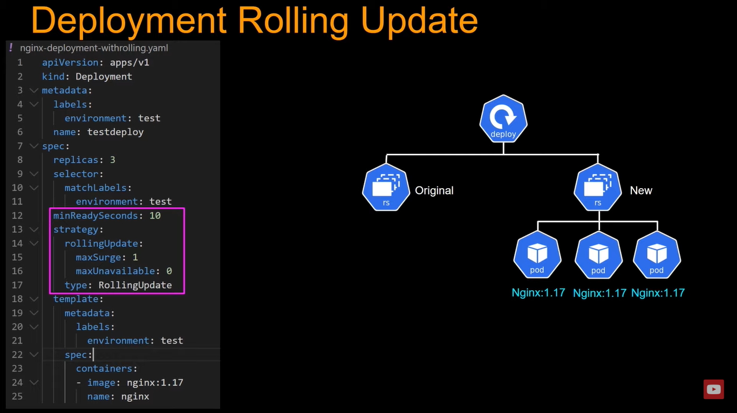

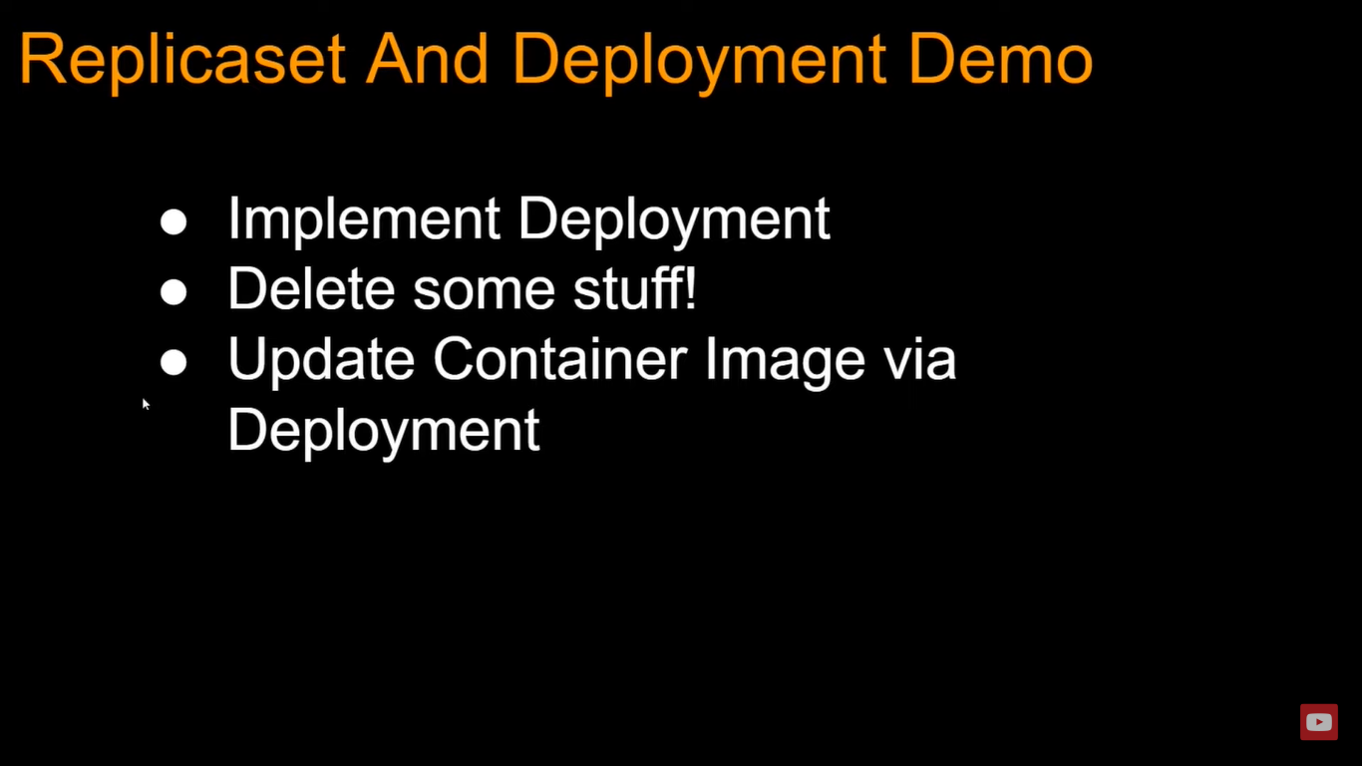

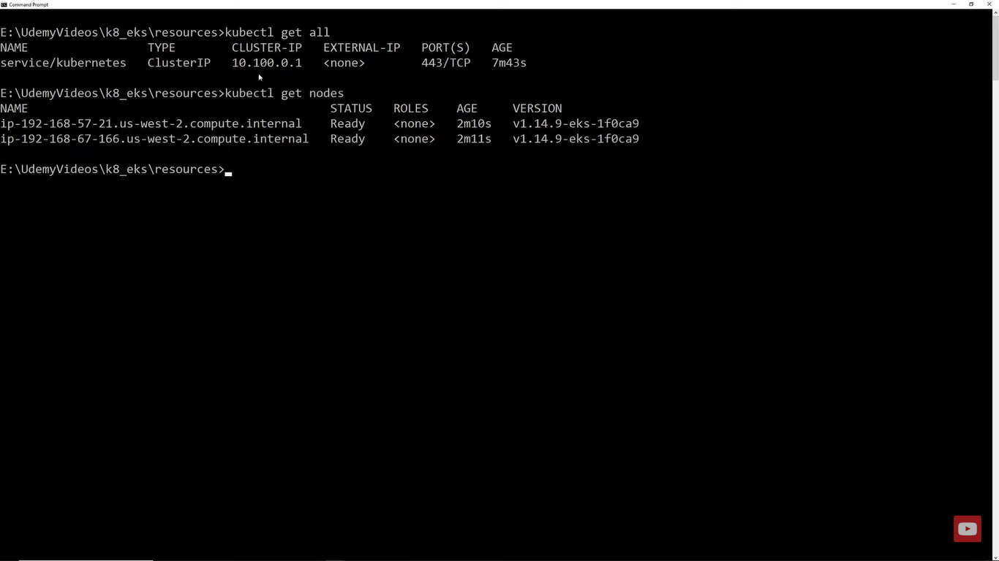

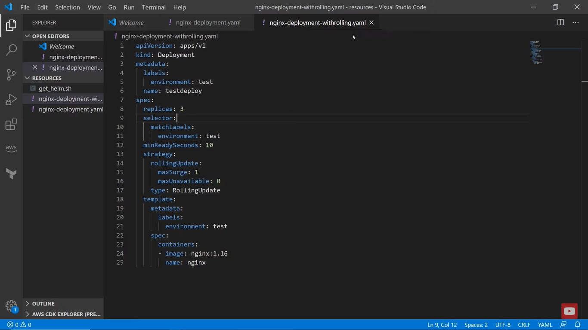

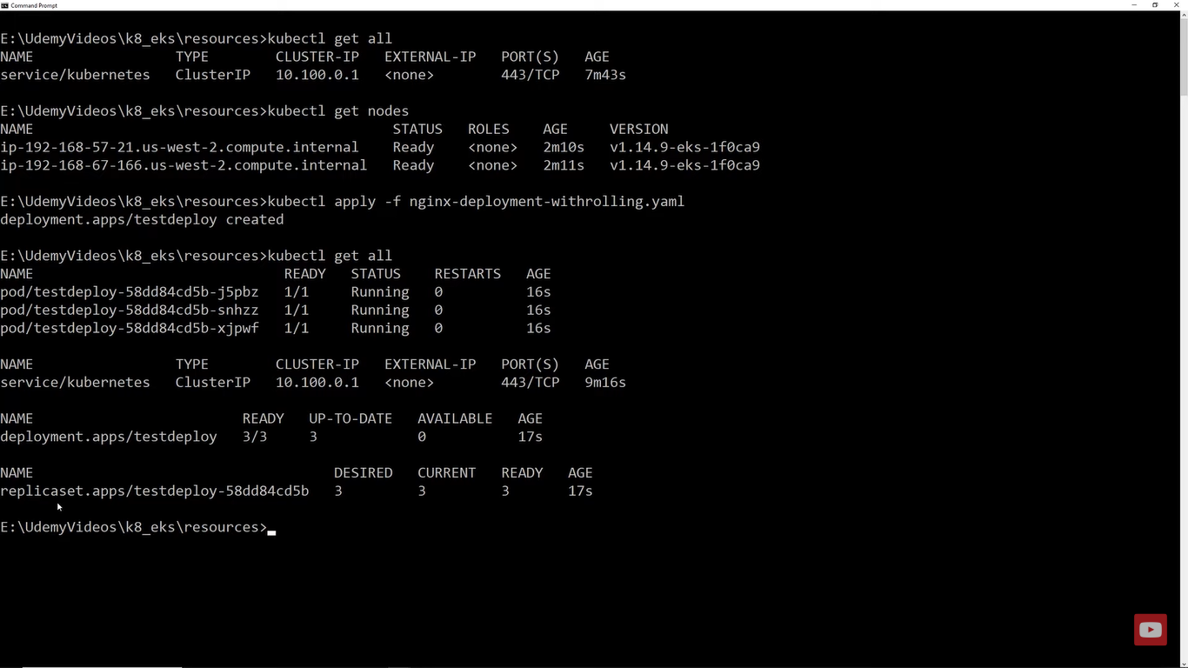

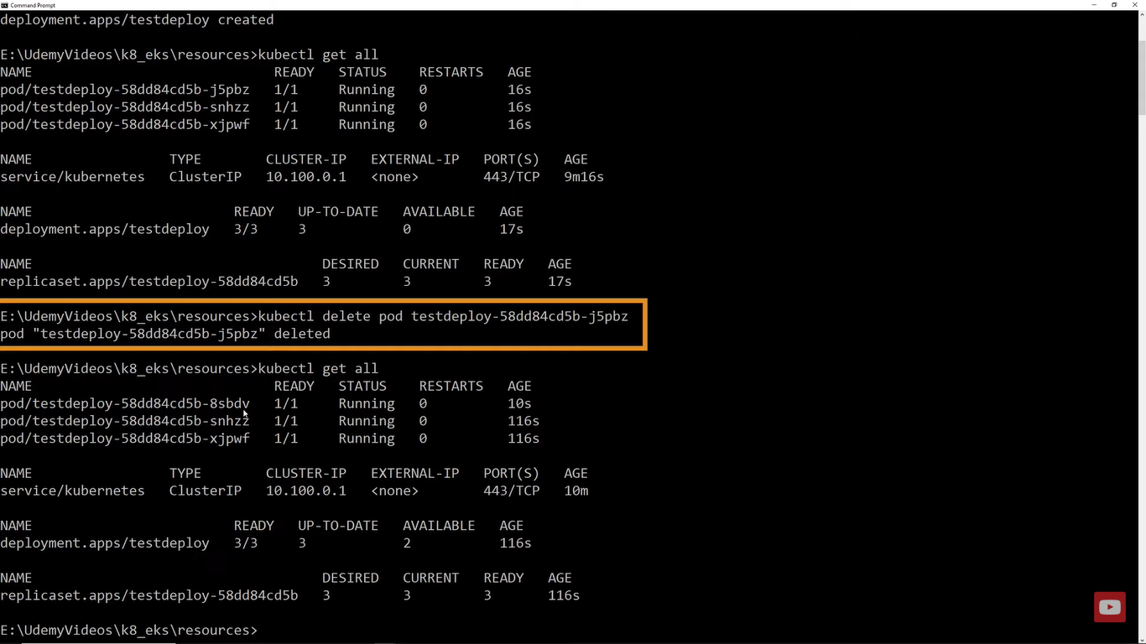

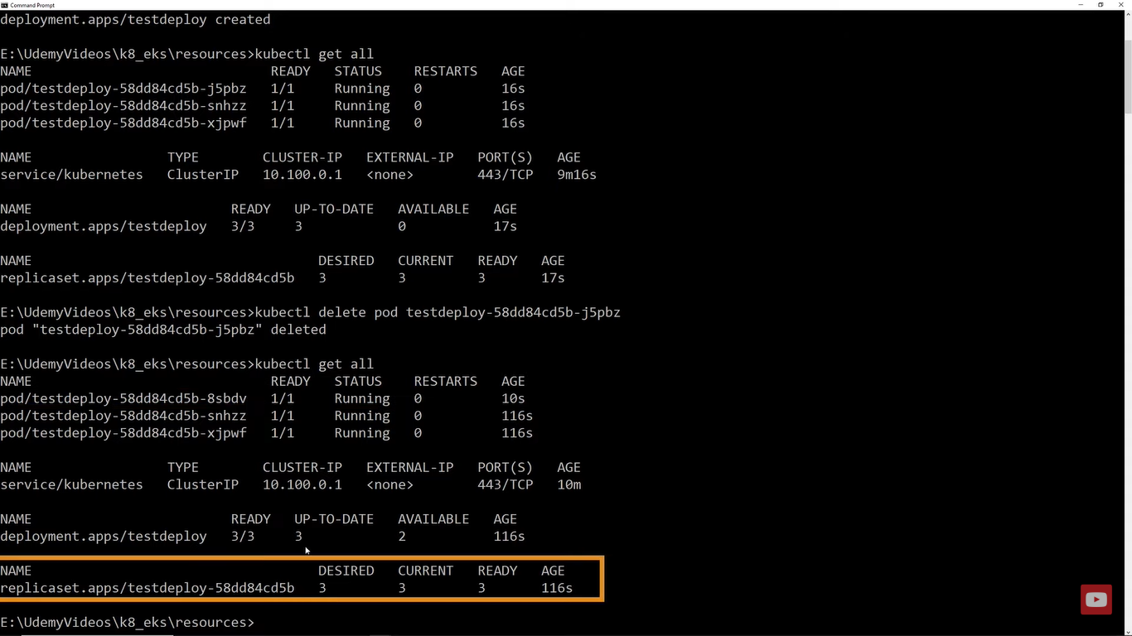

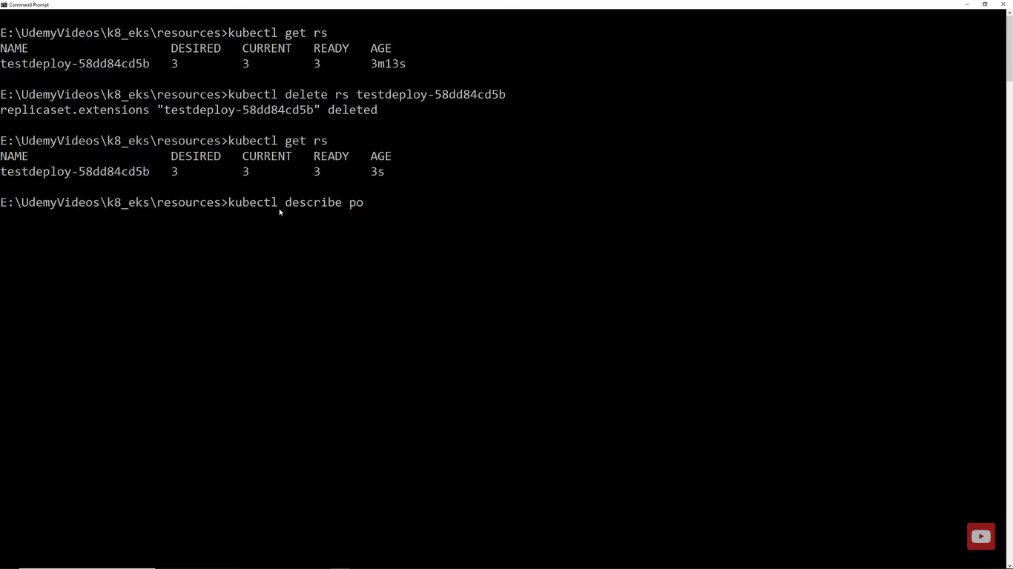

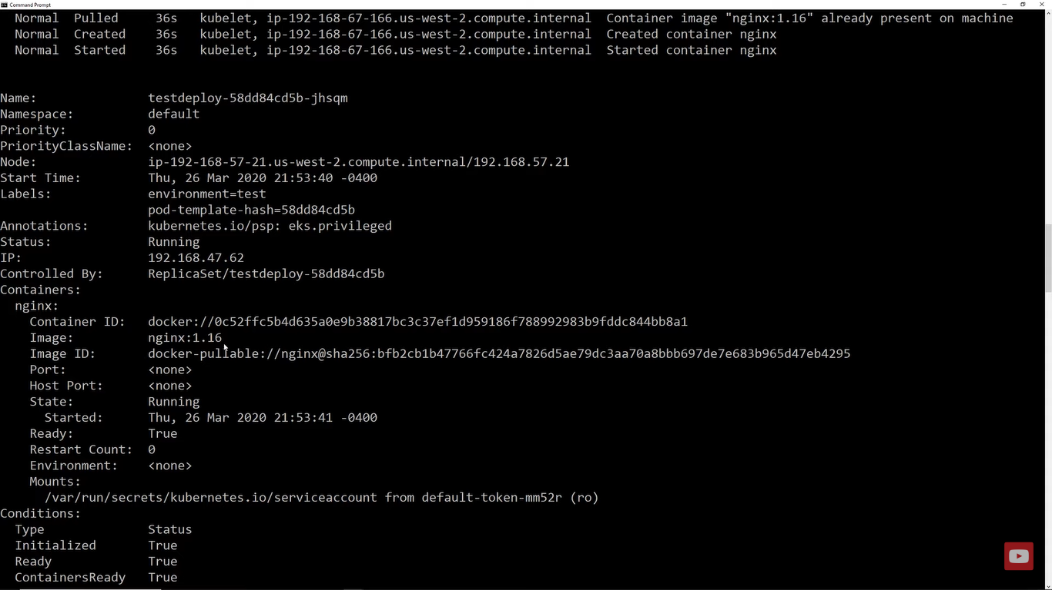

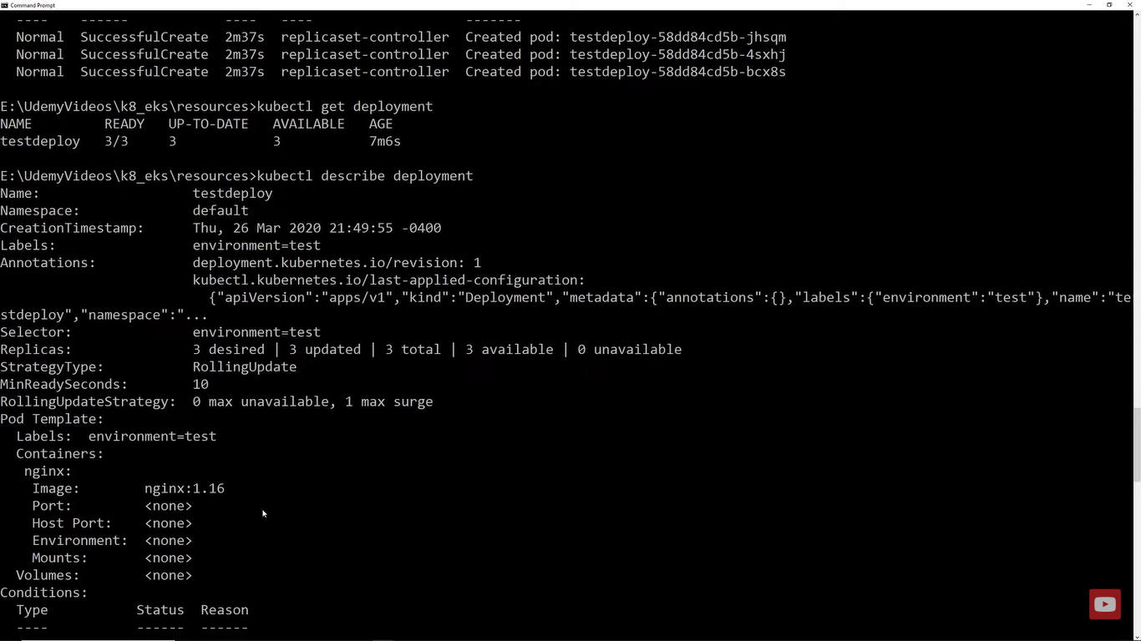

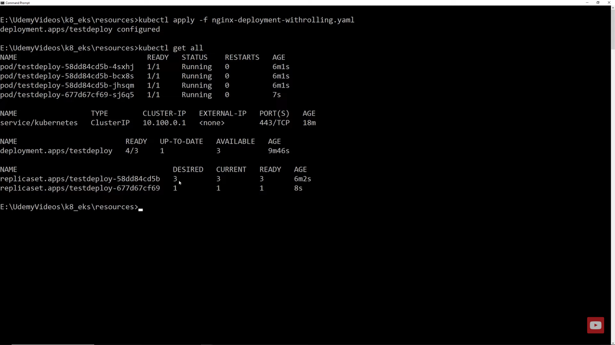

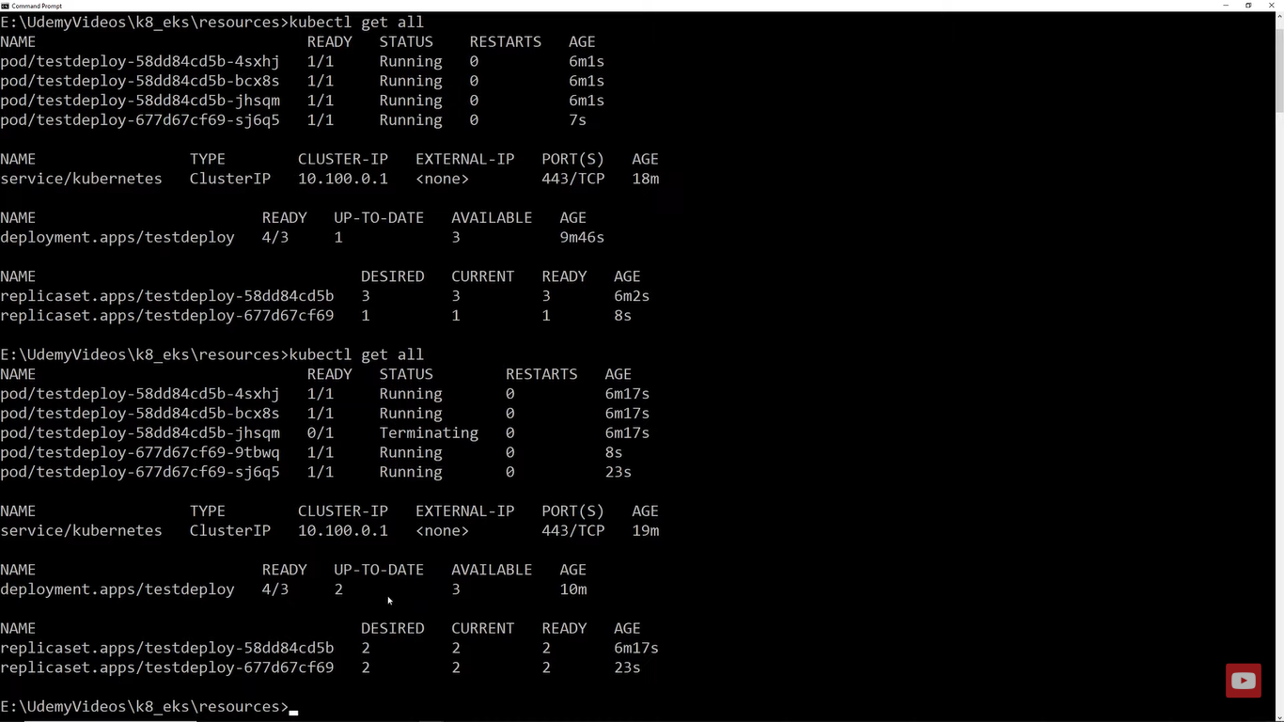

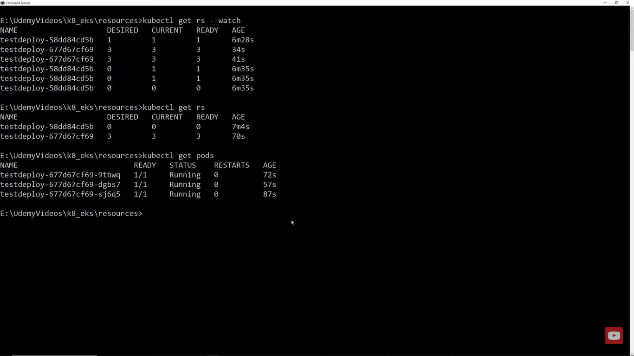

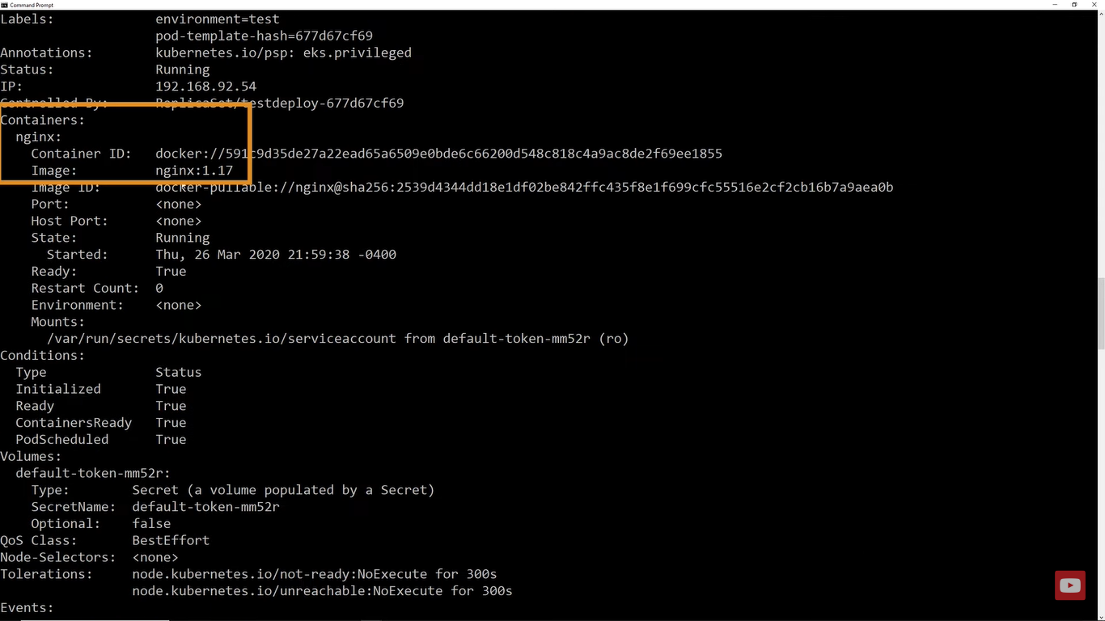

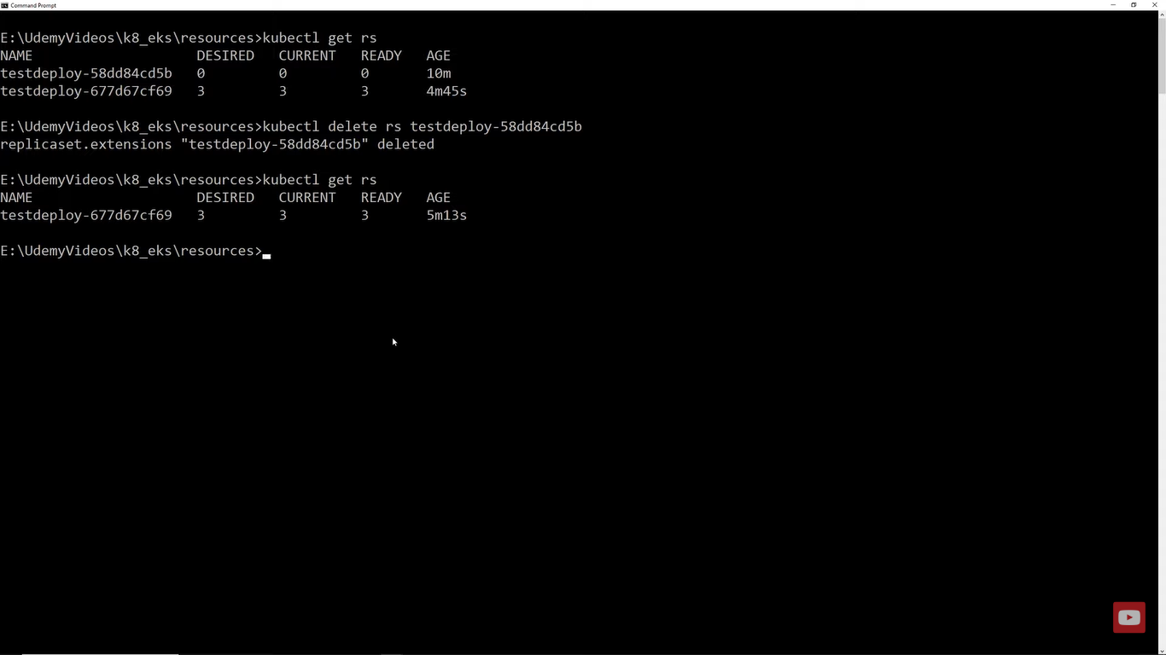

<https://www.middlewareinventory.com/blog/kubernetes-ingress-example/>

<https://docs.k0sproject.io/head/examples/nginx-ingress/>

<https://www.densify.com/kubernetes-autoscaling/kubernetes-service-load-balancer>

<https://computingforgeeks.com/deploy-nginx-ingress-controller-on-kubernetes-using-helm-chart/>

<https://oteemo.com/ingress-102-kubernetes-ingress-implementation-options/>

<https://rancher.com/docs/rancher/v2.0-v2.4/en/v1.6-migration/load-balancing/>

<https://docs.microsoft.com/en-us/samples/azure-samples/aks-multi-tenant-agic/aks-multi-tenant-agic/>

<https://www.ibm.com/cloud/blog/kubernetes-ingress>

<https://medium.com/devops-mojo/kubernetes-service-types-overview-introduction-to-k8s-service-types-what-are-types-of-kubernetes-services-ea6db72c3f8c#:~:text=There%20are%20four%20types%20of,is%20exposed%20to%20the%20network>.

[Top 25 AWS Services List 2021 (All AWS Services) | AllCode](https://allcode.com/top-aws-services/)